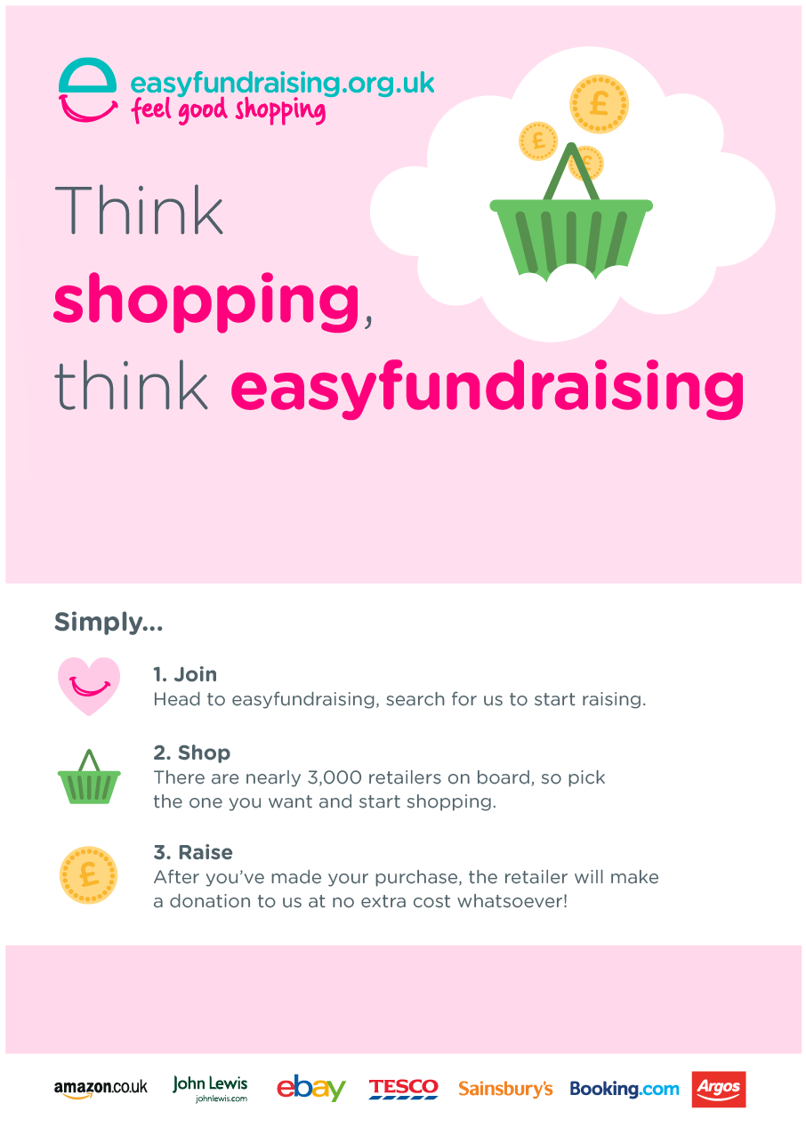

Don’t forget to help **INSERT CAUSE NAME** raise free donations. Remember easyfundraising.org.uk every time you shop online.

Don’t forget to help **INSERT CAUSE NAME** raise free donations. Remember easyfundraising.org.uk every time you shop online.

Join, shop and raise here:

easyfundraising.org.uk/**INSERT CAUSE PAGE ADDRESS**

Join, shop and raise here:

easyfundraising.org.uk/**INSERT CAUSE PAGE ADDRESS**